Unknown Cyber Portal and User Protection Setup Guide

Table of Contents
1. Open your browser to unknowncyber.com and then select “Pricing” from the top menu. 3
2. Click “Sign Me Up” 3
3. Continue through the membership checkout. 4
4. You will receive an email similar to the one below. Follow the link to complete your registration and create your Dashboard account. 4
5. Fill out the information requested and Click “Sign Up” 5
6. Check your email for a second verification like the sample below: 6
7. Login to “magic.unknowncyber.com” with your credentials after you have completed the email verification in Step 6. You will now be at the “Projects” page in your dashboard. 6
8. Click your user icon in the upper right corner. 7
9. Click Settings 7
10. Click “Exchange Settings → Connect Exchange” 8
11. Populate the “Tenant ID”, “Client ID”, and “Client Secret” from your vault or saved document from the user setup guide to the fields indicated below and then click “Subscribe” 8
12. Wait 5-7 minutes for the connection to complete initialization and then the “Subscribe/Unsubscribe” users and “Subscribe/Unsubscribe Groups” will now be selectable. 9
13. You can now select or deselect users for subscribing to Unknown Cyber protection and then click “Submit” to apply the changes. 9

1. Open your browser to unknowncyber.com and then select “Pricing” from the top menu.

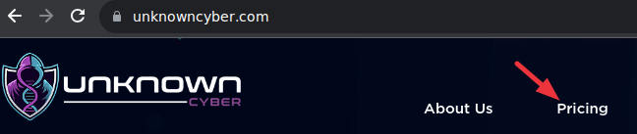

2. Click “Sign Me Up”

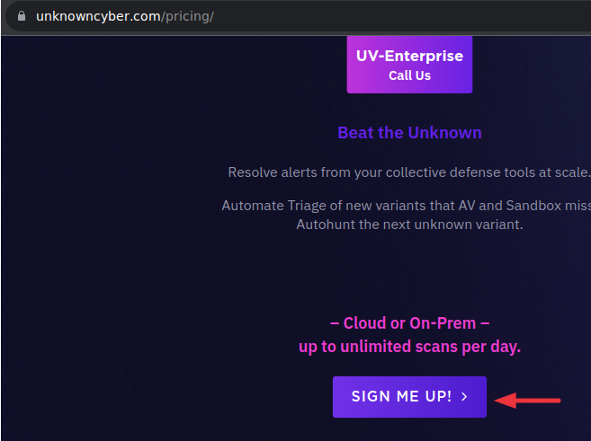

3. Continue through the membership checkout.

4. You will receive an email similar to the one below. Follow the link to complete your registration and create your Dashboard account.
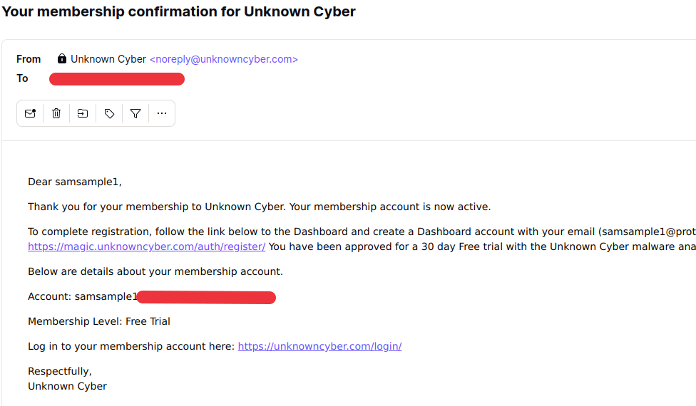

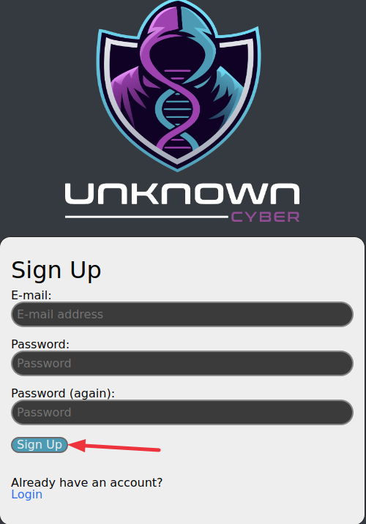
5. Fill out the information requested and Click “Sign Up”

6. Check your email for a second verification like the sample below:

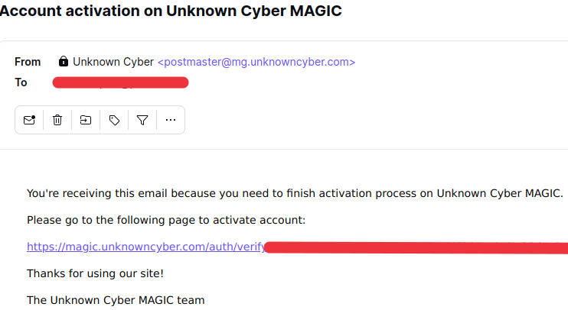

7. Login to “magic.unknowncyber.com” with your credentials after you have completed the email verification in Step 6. You will now be at the “Projects” page in your dashboard.

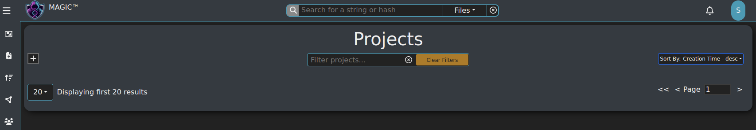

8. Click your user icon in the upper right corner.

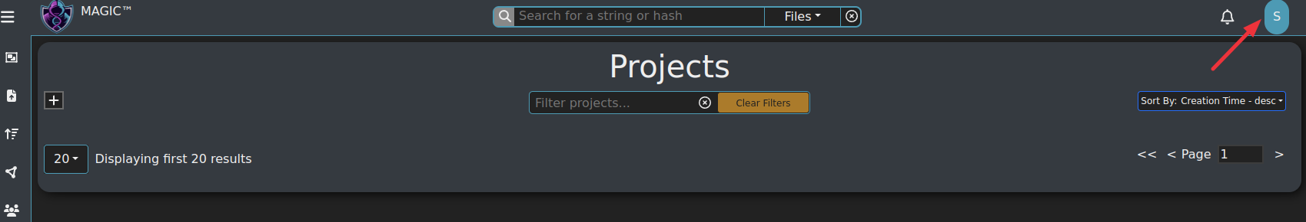

9. Click Settings
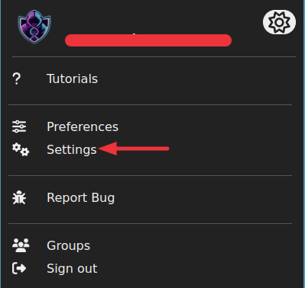

10. Click “Exchange Settings → Connect Exchange”

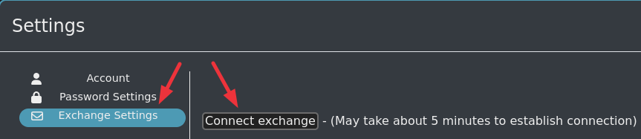

11. Populate the “Tenant ID”, “Client ID”, and “Client Secret” from your vault or saved document from the user setup guide to the fields indicated below and then click “Subscribe”

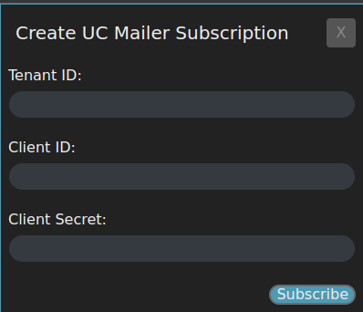

12. Wait 5-7 minutes for the connection to complete initialization and then the “Subscribe/Unsubscribe” users and “Subscribe/Unsubscribe Groups” will now be selectable.

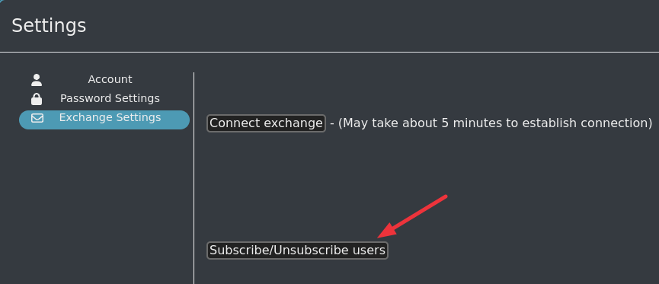

13. You can now select or deselect users for subscribing to Unknown Cyber protection and then click “Submit” to apply the changes.

